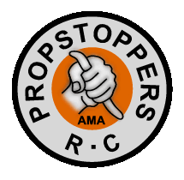
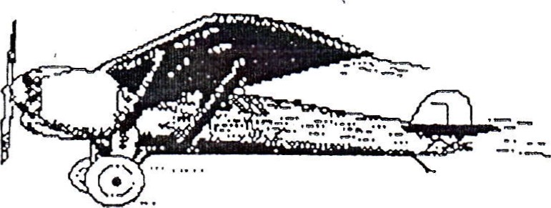

PROPSTOPPERS RC Club
Membership Application

PLEASE PRINT in BLOCK LEITERS

NAME ______________________________BIRTHDAY __________ AMA# __________

ADDRESS _______________________________ Apt. # _____ P.O. Box# ______

CITY ________________________ STATE __________ Zip ______________
HOME Phone ___________________ WORK/MOBILE Phone_________________

SPONSOR(S)_____________________________________________________________________

OTHER RADIO CONTROL CLUBS ______________________________________________

ABLITY LEVEL: NOVICE ____ PILOT ____ EXPERT ____ HOW LONG _______________________

PLANES_________________________________________________________________________

REASON FOR JONNG PROPSTOPPERS __________________________________________

ALL MEMBERS OF PROPSTOPPERS OPERATE UNDER BOTH THE AMA RULES AND CLUB RULES. BY SIGNING THIS APPLICATION YOU AGREE TO LEARN AND ABIDE BY THOSE RULES.THE PENALTY FOR VIOLATION MAY BE TERMNATION OF MEMBERSHIP. THESE CONDITIONS ARE ESSENTIAL FOR YOUR OWN PROTECTION AS WELL AS THAT OF THE MEMBERSHIP, the CLUBS AMA CHARTER AND USE OF FIELD PROPERTIES.
1 HAVE READ THE ABOVE STATEMENT. I UNDERSTAND AND AGREE TO MY OBLIGATION,

SIGNATURE DATE
EMAIL

FORWARD to: Ken Merlino at kenmer31@yahoo.com
31 Martin Lane
Norwood, PA 19074

