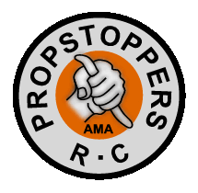
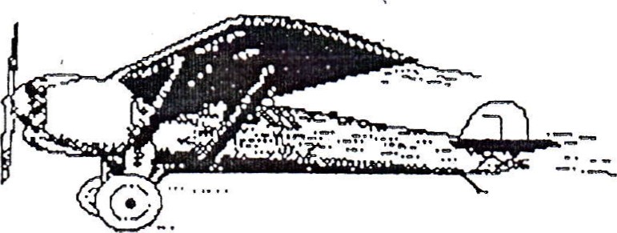

PROPSTOPPERS RC Club
Membership Application
PLEASE PRINT in BLOCK LETTERS

NAME _____________________________ BIRTHDAY __________ AMA# ___________

ADDRESS ______________________________________ APT ______ P.O.BOX ______

CITY ___________________________ STATE __________ ZIP __________________
HOME Phone# __________ MOBILE # ___________ WORK # _______________

SPONSOR(S) ____________________________________________________________________

Do you belong to other Model Aviation clubs? ___________________________

SKILL LEVEL: NOVICE ____ EXPERT ____ HOW LONG FLYING: __________________

PLANES YOU OWN: _______________________________________________________________

REASON FOR JOINING PROPSTOPPERS: _______________________________________
ALL PROPSTOPPERS CLUB MEMBERS OPERATE UNDER BOTH THE AMA RULES AND CLUB RULES. BY SIGNING THIS APPLICATION YOU AGREE TO LEARN AND ABIDE BY THOSE RULES. THE PENALTY FOR ANY VIOLATION MIGHT BE TERMINATION OF MEMBERSHIP. THESE CONDITIONS ARE ESSENTIAL FOR YOUR OWN PROTECTION AS WELL AS THAT OF THE MEMBERSHIP, THE CLUBS AMA CHARTERS AND USE OF FIELD PROPERTIES.
I HAVE READ THE ABOVE STATEMENT. I UNDERSTAND AND AGREE TO MY OBLIGATIONS.

SIGNATURE ____________________ DATE ______________

EMAIL ADDRESS: _________________________________________________________

PLEASE FORWARD TO: throttle152@hotmail.com OR mail to:

Ryan Schurman

5200 Hilltop Drive

Condo HH 23
Brookhaven, PA 19015

